Full Page - $200

Up to 12 pictures.

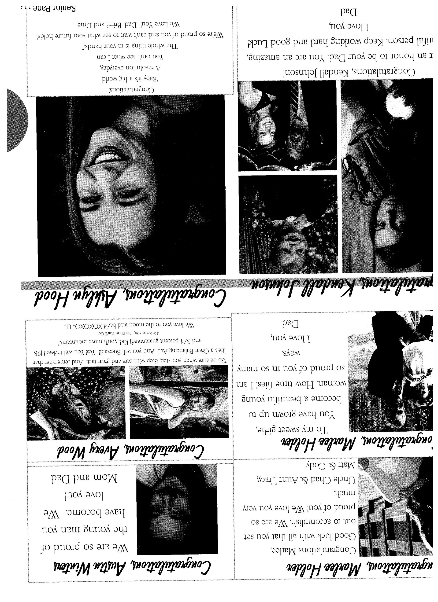

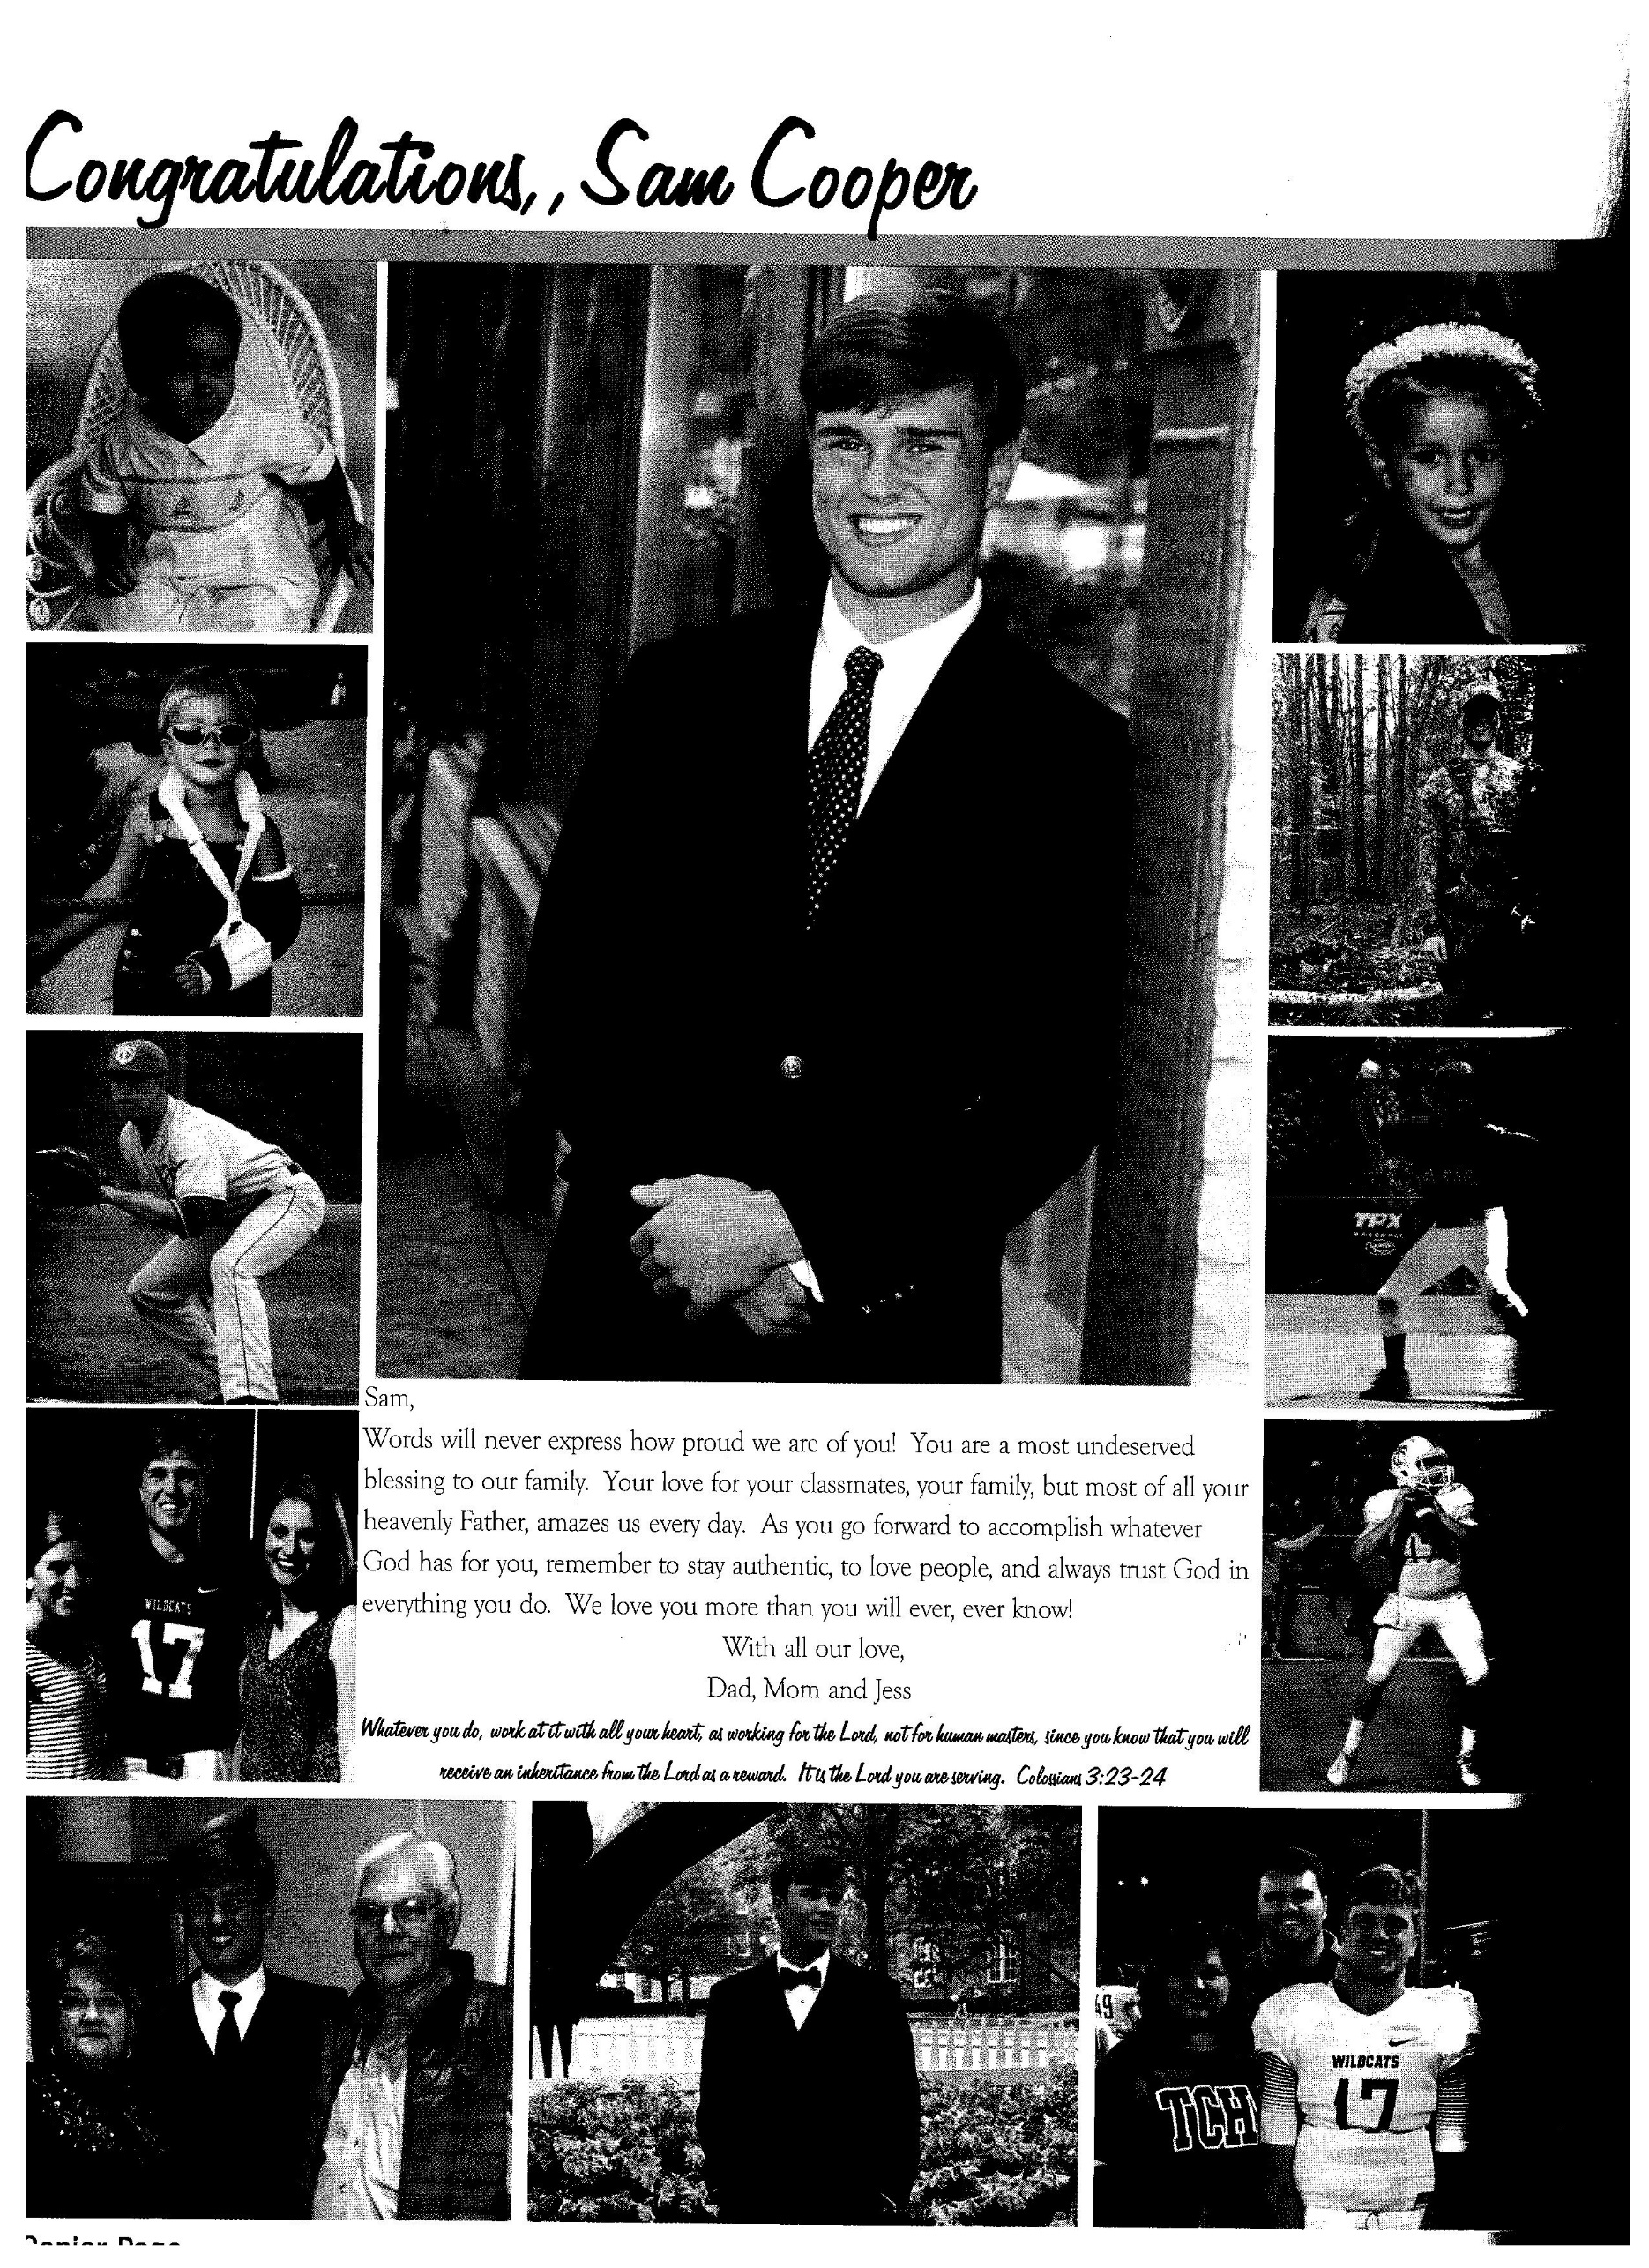

Eighth page - $85.

1-2 pictures.

Quarter page - $100

Up to 3 pictures.

Half page - $150

Up to 6 pictures.

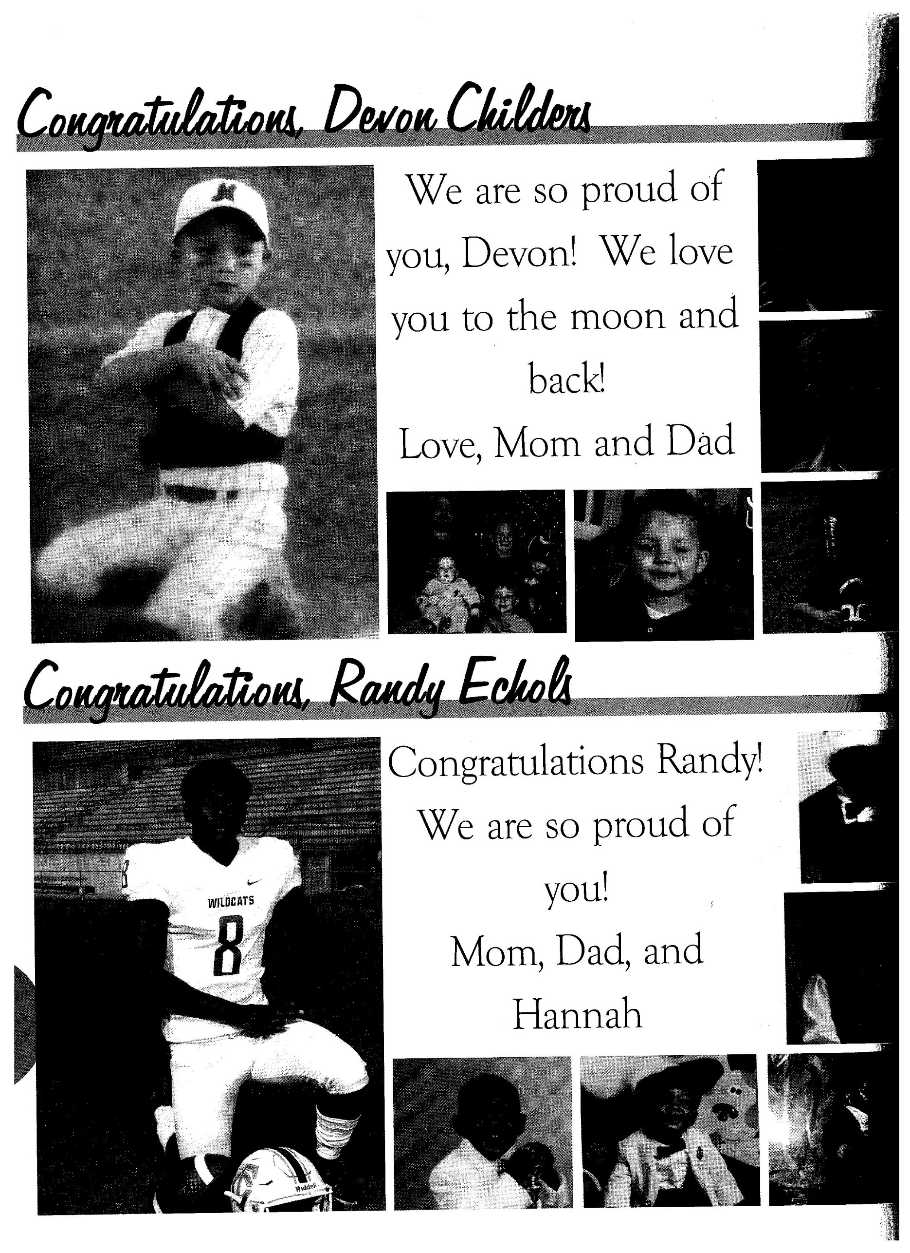

When sending pictures/message, you may choose one of the following ways:

-Scan and email pictures to [tuscohiyearbook@gmail.com](mailto:tuscohiyearbook@gmail.com).(RECOMMENDED)

-Scan and send pictures on flash drive or disc. (RECOMMENDED)

-Send the actual pictures in an envelope and we will scan .

We HIGHLY RECOMMEND that you submit your pictures by email, flash drive or disc. We have the capability to scan pictures, but the process is tedious, and we would rather not handle your precious photos. If it is absolutely necessary for you to send photos for us to scan, **please make sure that EACH PHOTO has the student’s name on the back, all photos are placed in a large manila envelope with the student’s name, a VALID PHONE #, and EMAIL ADDRESS on the outside of the envelope.**

Things to Remember…………………….

-DO NOT SEND PHOTOS IN A .PDF FORMAT. You will be asked to resubmit the photos if they are sent in a .pdf.

-Absolutely no naked baby photos will be published, regardless of gender.

-No pictures with guns will be published. This includes hunting photos. You can still publish the photo of you in the camo and the 9 point!

-Your message should be short and to the point. The more words, the less amount of room for pictures.

How do I send materials for the senior page?

Important Note to Parents:

The TusCoHi staff works tirelessly on the senior ad pages. We desire for every page to be perfect and to represent your senior in the best possible way. Please be aware, however, that even with the best possible efforts, occasional errors can occur. Please remember that we are a student publication. We take pride in our yearbook and it is important to us to do an excellent job. However, in the unfortunate event that an error occurs, refunds are not available for senior ad pages. Thank you for your understanding.

Deadline to purchase is December 3th, 2021

TusCoHi, 12500 Wildcat Drive, Northport AL 35475

Phone: 205-342-2670 Fax: 205-333-3197 [tuscohiyearbook@gmail.com](mailto:tuscohiyearbook@gmail.com)

Yearbook Sponsor: Paige Cooper

Congratulations to the class of 2022!

**Because the yearbook is entered for competition, which means continuity is very important, the yearbook staff will design the page layout, including font, spacing, etc. Please do not send completed pages or .pdf pages.**

Are you proud of your TCHS senior? Congratulate your graduate with a senior page in the 2022 yearbook!!

An entire section of the yearbook is reserved for parents, siblings, and friends of seniors to submit notes of congratulations or best wishes and various pictures throughout the senior’s life.

Who will proof my page?

Yearbook pages cannot *and will not be kept a secret or “as a surprise*” for your graduate. Students will be asked to proof their own page before it is sent for publication.